**Aim:** Connecting and extracting with various data resources in tableau.

**Theory:**

**Steps:**

1.From the home screen, click the Connect to Data button. From the Connect pane, select Tableau extract.

2.There are various options given to open the extracted data in csv , xls and json.

3.After the extracted data is opened in the worksheet in the right hand side there is show me option click on that and apply the suitable graph in it .

**Output :**

* Excel File

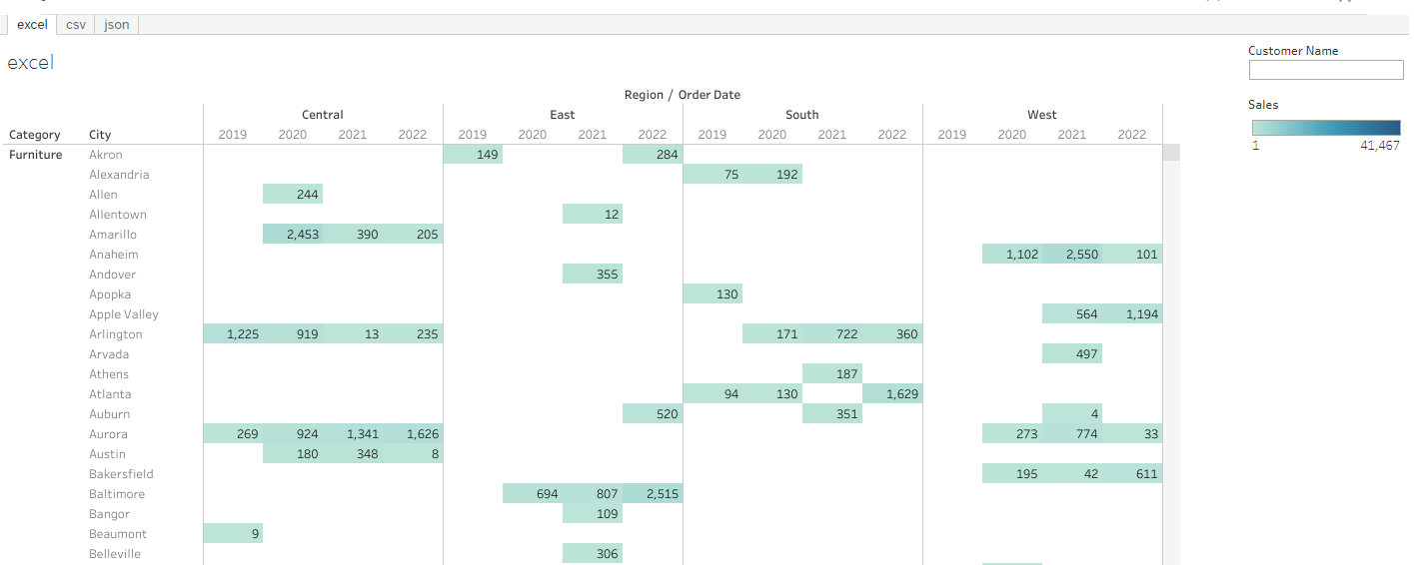

* CSV File

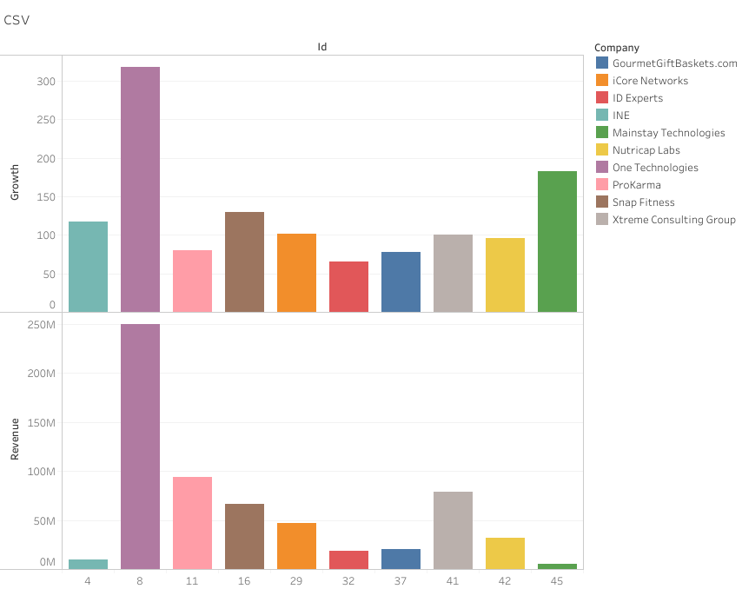

* json file

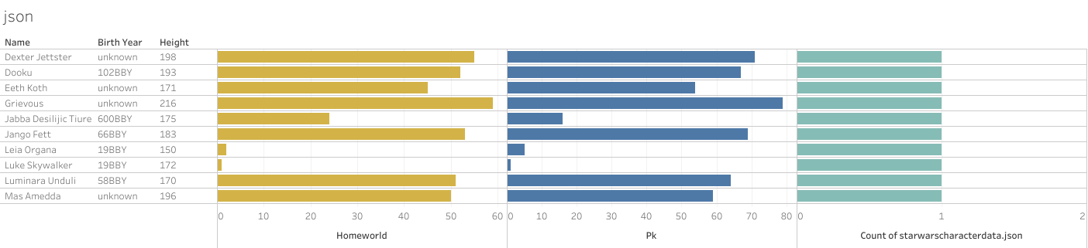

**Result:**

We have opened different file and and obtained the graph of it to get the visual representation of the data.